
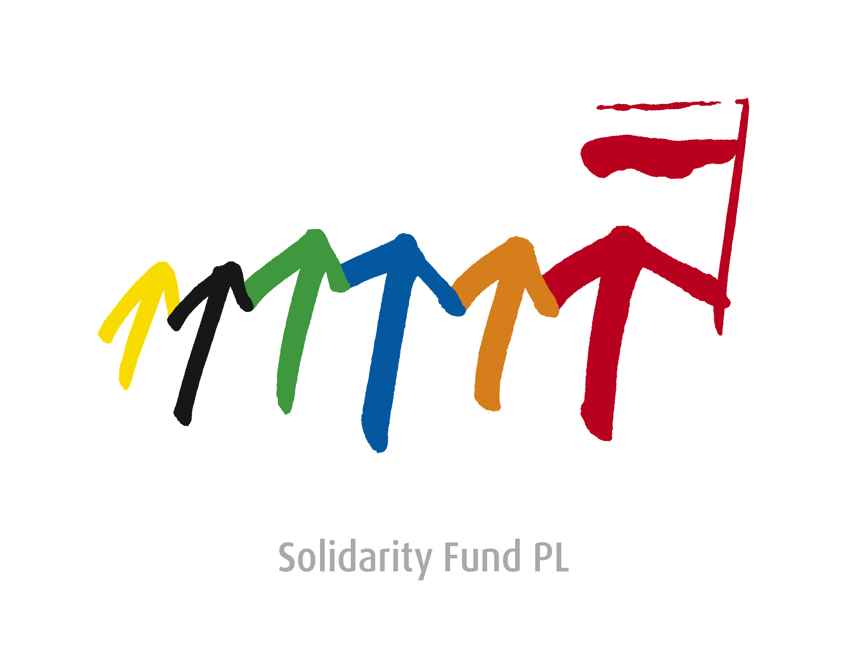

Decentralisation and Community Development in Ukraine
Chernihiv, April 20-21, 2015

Official working languages: English and Ukrainian
Venue: Chernihiv Regional Council building

Monday, April 20, 2015
Transfer from Kiev to Chernihiv (bus), Registration

12:30-13:30 Round table - Decentralisation and Community Development in Ukraine

Welcome addresses and opening remarks
- Konrad Pawlik, Deputy Foreign Minister of Poland (Chair);
- Nataliia Galibarenko, Deputy Foreign Minister of Ukraine;
- Peter Burian, Deputy Foreign Minister of Slovakia;
- Jaroslav Ludva, Junior Deputy Foreign Minister of the Czech Republic;
- Mikola István Minister of State of the Ministry of Foreign Affairs and Trade of Hungary;
- Roman Waschuk, Ambassador of Canada to Ukraine;
- Christof Weil, Ambassador of the Federal Republic of Germany in Ukraine;
- Valeriy Kulich, Head of Chernihiv Oblast State Administration (tbc);
- Mykola Zveriev, Chairman of Chernihiv Oblast Council (tbc).

13:30 - 14:00 The Roadmap for the Decentralisation Reform in Ukraine - Keynote Panel
- Viacheslav Negoda, Deputy Minister, Ministry of Regional Development of Ukraine;
- Representative of the Ministry of Finance of Ukraine (tbc)

From 14:00 - Press conference of V4 + UA Deputy Ministers

14:00-18:45 Side events hosted by the Solidarity Fund PL

15.30-17:00 The Role of Ukrainian Civil Society in the Ukrainian Local Government Reform

Moderator: Oleksander Slobodzhan, representative of the Association of Ukrainian Cities;
Oksana Syroid, Deputy Chairman of the Verkhovna Rada of Ukraine;
Anatoliy Tkachuk, President of the Civil Society Institute in Kyiv (tbc);
Ihor Koliushko, Head of the Board, Center for Political and Legal Reforms;
Evgeniy Udod, Head of Regional Council, Dnipropetrovsk Region;
Designated discussants:
Local government representative (tbc);
Media Konstantin Kvurt, the executive director of Internews-Ukraine.

17:00-17:15 Coffee break
17:15-18:45 Enhancing Reforms in Ukraine

Moderator: Krzysztof Stanowski - President of the Solidarity Fund PL;
Marcin Święcicki, MP, coordinator of the Polish experts’ team in the Polish-Ukrainian Advisory Council for the local government reform in Ukraine;
Roman Waschuk, Ambassador of Canada to Ukraine (tbc)
Pavol Demes, German Marshall Fund od the US, expert on international relations and the former Minister of International relations SR:
- The task of NGOs in decentralization;
Mr. Mihály DÁN, expert on e-governance in the Ministry of Interior of Hungary;
Daniel Popescu, Head of the Centre of Expertise for Local Government Reform of the Council of Europe (tbc)
Guido Beltrani, Director of the Swiss Cooperation Office Ukraine;
Lars-Eric Ericsson, Senior Advisor, SKL International;
Cord Hinrich Meier-Klodt, Director for Eastern Europe, the Caucasus and Central Asia, Federal Foreign Office, Berlin;
Kristina Mikulova, Head of a separate department for Development Cooperation of the Ministry of Finance of the SR;
- Fiscal decentralization as part of the reform of public finances in the Slovak Republic.

18.45 Round table - Closing remarks
- Viacheslav Negoda Deputy Minister for Regional Development, Construction, Housing and Utilities (tbc)
- Konrad Pawlik, Deputy Foreign Minister of Poland.
19.00 Press Briefing

Tuesday, April 21

09:30-10:30 Meeting of Deputy Foreign Ministers with students at Chernihiv National University of Technology

10:00-12:00 Side events hosted by the Solidarity Fund PL
Parallel informal thematic sessions;
The Role of Civil Society in the Ukrainian Local Government Reform
("Prydesniansky" Hotel);

Zuzana Fialova, Public union “People in danger”, SK:
- Civil participation - involvement of citizens in decision-making. The experience of Slovakia.

Vladislav Vik, People in Need, Desk Officer Ukraine, CZ:
- Civic engagment in decision making process.

Media and the Decentralization Reform
("Prydesniansky" Hotel);
Donor Coordination Meeting
(Park Hotel “Chernihiv”)

Karla Vursterova, Director IVF:
- IVF and Decentralisation and Community Development in Ukraine.

